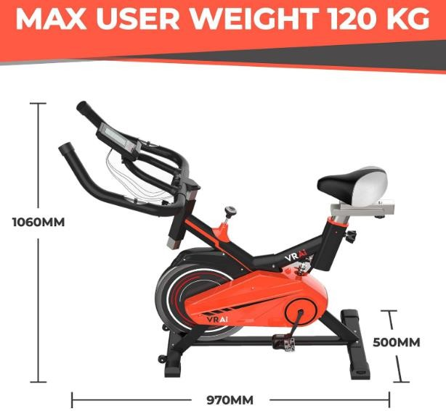

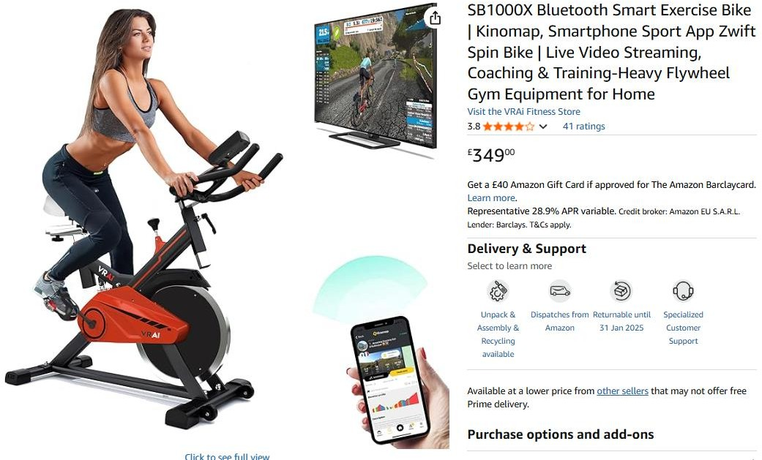
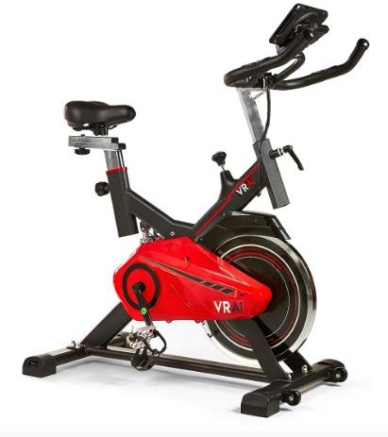
115pcs x SB1000X Bluetooth Smart Exercise Spin Bike…………Selling on amazon for £349 Cost £79

